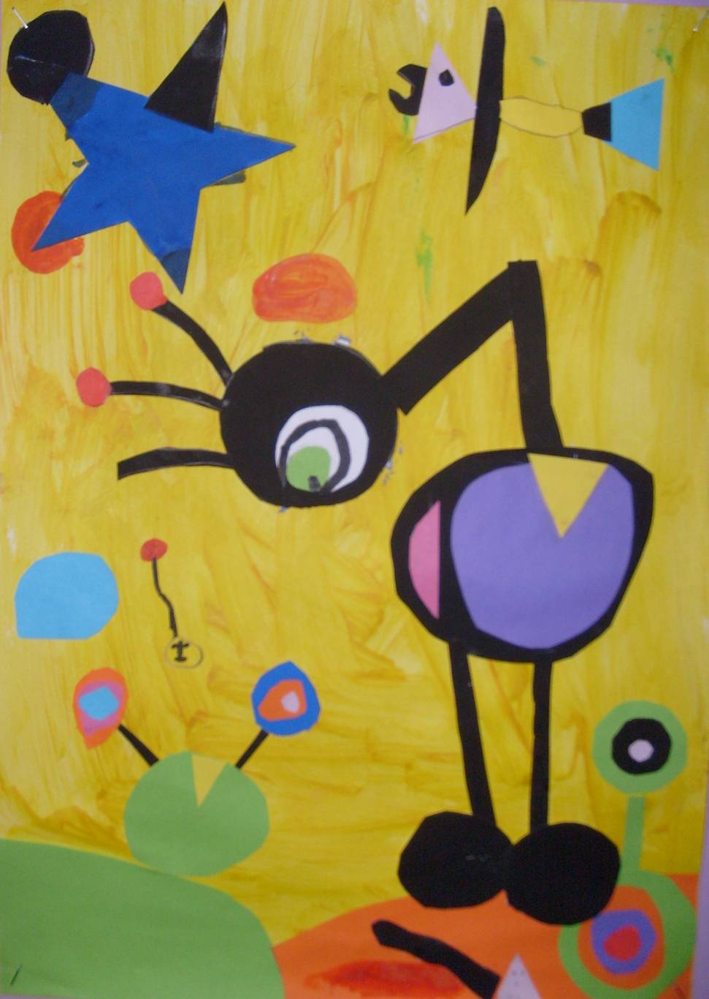
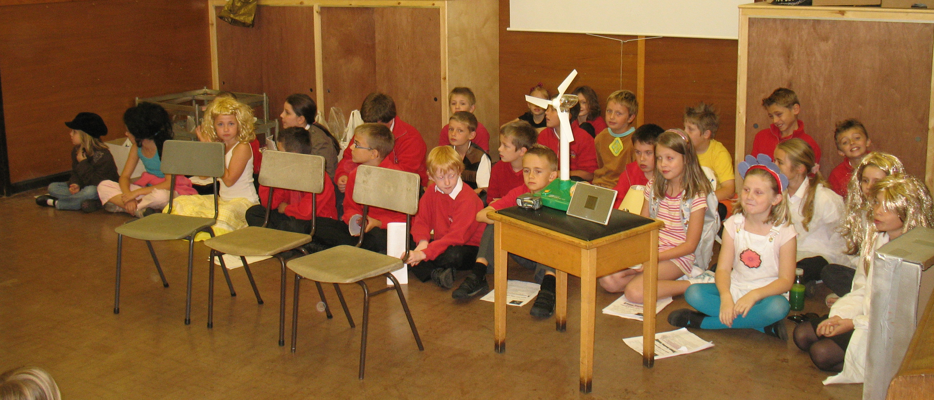
Written by: .

I have learned new things like | In maths I have learned
At work, I have enjoyed  because | I haven’t enjoyed this so much  because
I have been really good at | I have got better at
These things have helped me with my work  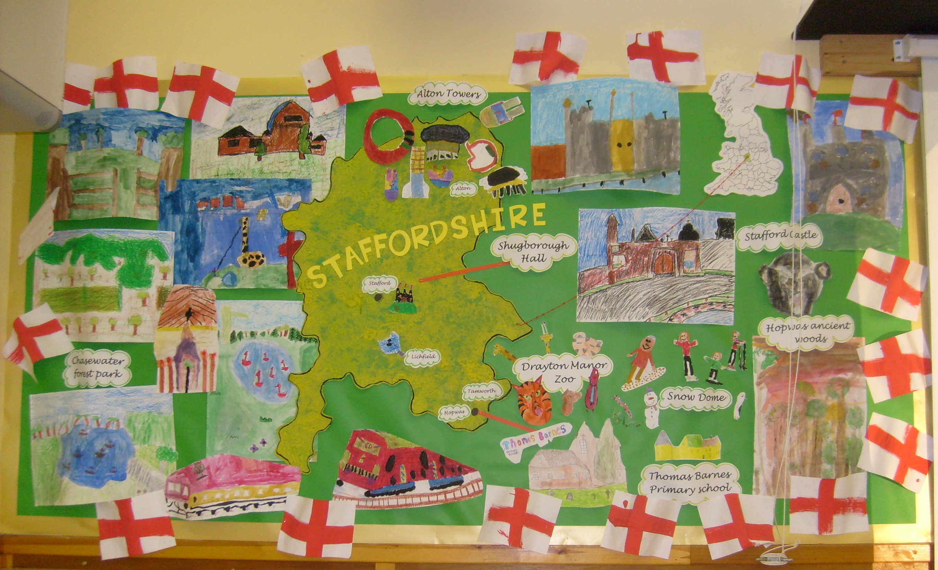 | A target for next half term could be

