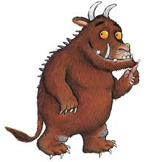
This term I have learned | I have got better at
I am very proud of | This would have helped me with my learning / made it even better in class
Next term I would like to learn | I will try hard to improve

